**TROUBLESHOOT AT THE APPLICATION LEVEL**

**STEPS TO CHECK APACHE SERVER STATUS**

When one or all the Apache servers are down

**Step 1**: To check the status of Apache, use the command "***systemctl status httpd***".

**Step 2**: The command should be executed on all DC servers. If the DC failover to DR, it should be checked on the DR servers.

|  |  |
| --- | --- |
| **DC Servers** | **DR Servers** |
| 192.168.155.15 | 192.168.145.15 |
| 192.168.155.16 | 192.168.145.16 |
| 192.168.155.17 |

**STEPS TO CHECK SERVICES STATUS**

When one or all the services are down  
  
**Step 1**: Check the services on all DC and DR Servers by logging in to each one.

**Step 2**: To check the services in each server, please run the following APIs on all DC servers. If the DC failover to DR, it should be checked on the DR servers.

|  |  |
| --- | --- |
| APIs | Shell Script |
| curl --location 'http://127.0.0.1:8080/api/admin/hb' | 2RunSvrJarAdmin.sh |
| curl --location 'http://127.0.0.1:8080/api/auth/hb' | 3RunSvrJarAuthentication.sh |
| curl --location 'http://127.0.0.1:8080/api/em/hb' | 6RunSvrJarEmigrant.sh |
| curl --location 'http://127.0.0.1:8080/api/fr/hb' | 7RunSvrJarForeignEmployer.sh |
| curl --location 'http://127.0.0.1:8080/gws/hb' | 1RunSvrJarGateway-api.sh |
| curl --location 'http://127.0.0.1:8080/api/gs/hb' | 12RunSvrJarGrievanceService.sh |
| curl --location 'http://127.0.0.1:8080/api/is/hb' | 15RunSvrJarInsurance.sh |
| curl --location 'http://127.0.0.1:8080/api/ns/hb' | 9RunSvrJarNotification |
| curl --location 'http://127.0.0.1:8080/api/payment/hb' | 14RunSvrJarPayment.sh |
| curl --location 'http://127.0.0.1:8080/api/rs/hb' | 10RunSvrJarReport.sh |
| curl --location 'http://127.0.0.1:8080/api/ra/hb' | 8RunSvrJarRecruitAgent.sh |
| curl --location 'http://127.0.0.1:8080/api/ss/hb' | 4RunSvrJarSecurity.sh |
| curl --location 'http://127.0.0.1:8080/api/wf/process/hb' | 5RunSvrJarWorkflow.sh |

**Step 3**: Once you have identified which services are currently unavailable or not working properly, you can begin to address the issue.  
eg: Error message (connection refused and APIs are not responding)

**Step 4**: Please follow the path mentioned below.  
***/opt/emigrate/server/packages/***

**Step 5**: Please use the command to display a list of only the files with the .sh extension, which are Shell Script files for restarting the services.  
***ls -alt *.sh***  
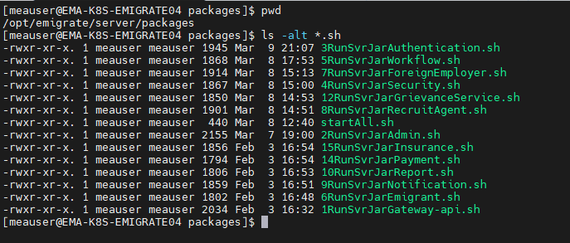

**Step 6**: Please execute the shell script that is associated with the service(s) APIs that are currently down.

**Step 7**: After executing the shell script, you can use the command **‘*ps –ef | grep java’*** or the respective API to check if the services are running.

**Step 8**: After all the services are up and running, do a Root Cause Analysis (RCA) for any services that were down by checking the logs ( gcLogs, accessLogs and applicationLogs)  
***/opt/emigrate/logs***

**DC Prod Application Servers DR Prod Application Servers**

|  |  |
| --- | --- |
| 192.168.155.18 | 192.168.145.17 |
| 192.168.155.19 | 192.168.145.18 |
| 192.168.155.20 | 192.168.145.19 |
| 192.168.155.21 |
| 192.168.155.22 |

ELK URLs

|  |  |  |  |
| --- | --- | --- | --- |
| IPs | URLs | ENV | CREDENTIALS |
| 192.168.155.23 | <http://192.168.155.23:5601/>login | DC Prod | [logviewer/account@123](mailto:logivewer/account@123) |
| 192.168.145.20 | <http://192.168.145.20:5601/login> | DR Prod | [logviewer/account@123](mailto:logivewer/account@123) |
| 172.16.100.20 | http://172.16.100.20:5601/login | NON Prod | [logviewer/account@123](mailto:logivewer/account@123) |

Check disk space, memory, and CPU utilization for ELK and all application servers.

NFS Mount Server

|  |  |
| --- | --- |
| IPs | ENV |
| 192.168.155.24 | DC Prod |
| 192.168.145.21 | DR Prod |

Check disk space, memory, and CPU utilization for NFS mount and Database servers.

DB Servers

|  |
| --- |
| IPs |
| 10.40.10.5 |
| 10.40.10.6 |
| 10.100.20.3 |

Check disk space, memory, and CPU utilization for DB mount and Database servers.